Add User SCN 002 Verify that there are no copywriting errors in List user TC 001
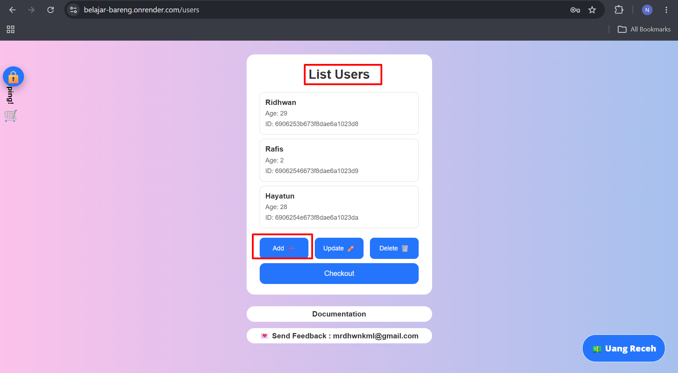

Add User SCN 002 Verify Add button can be click TC 002
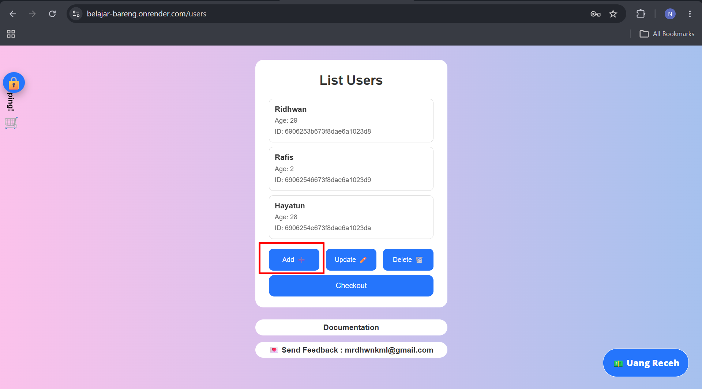
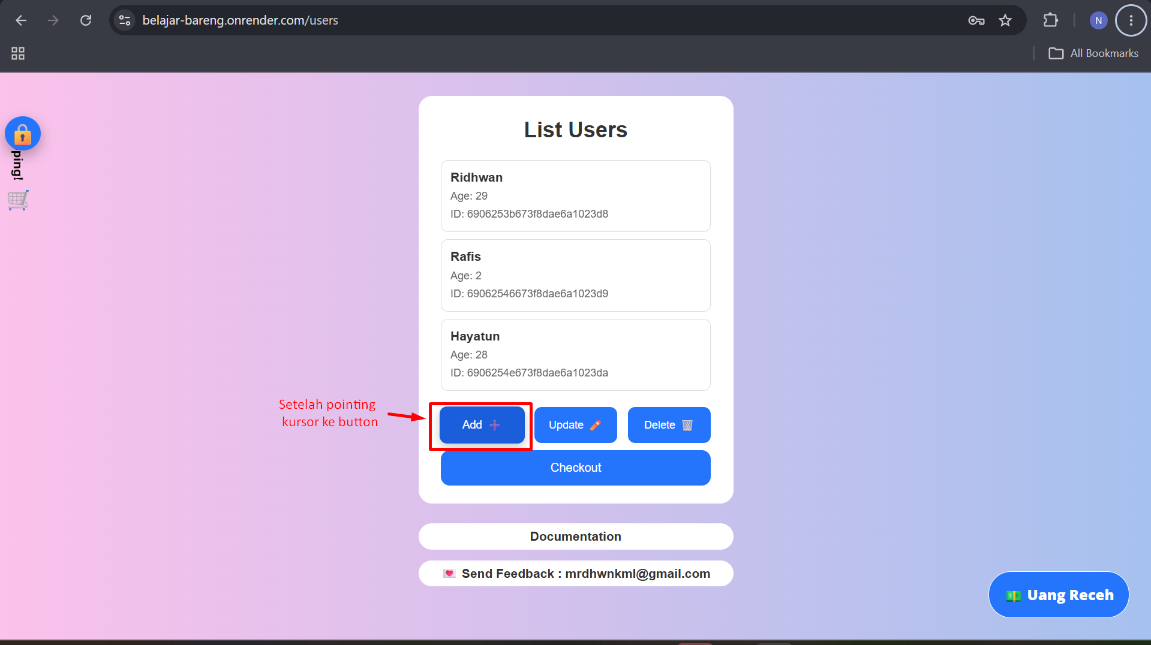
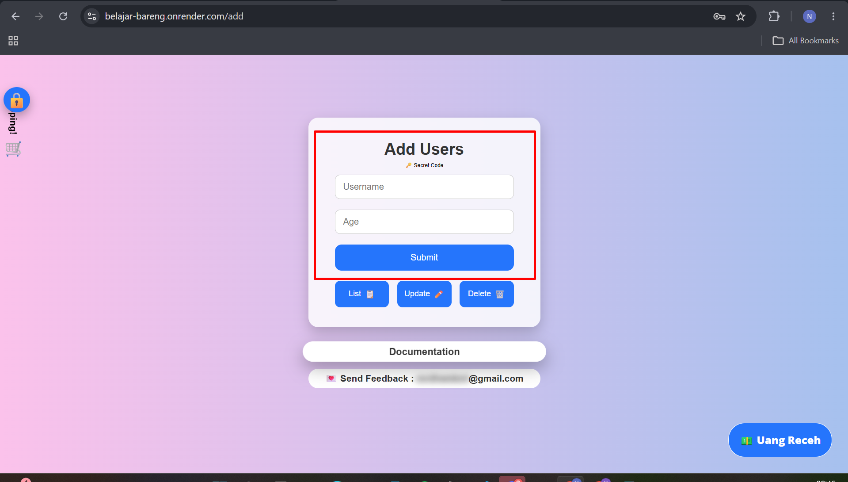

Add User SCN 002 Validate user can add new user TC 003
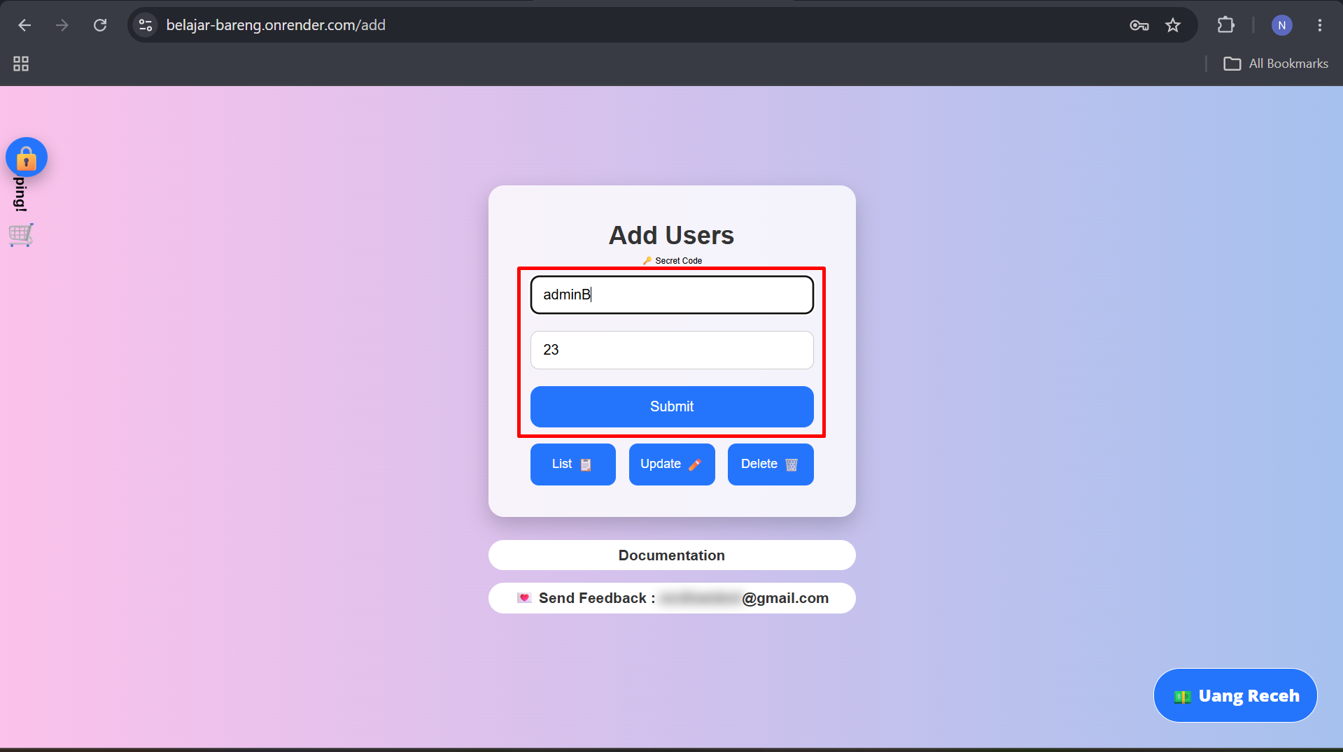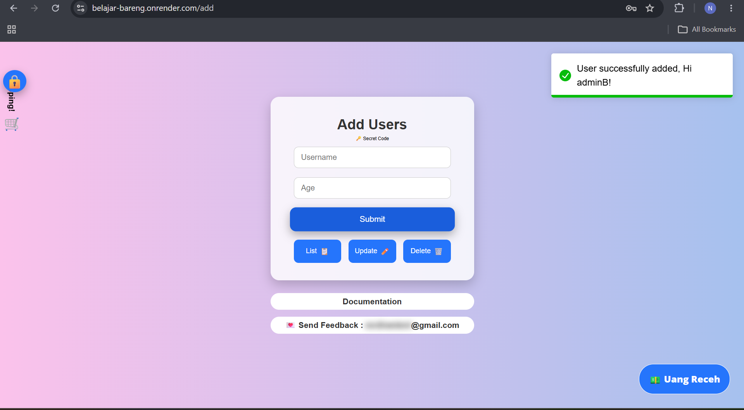

Add User SCN 002 Validate maximum input for username TC 004
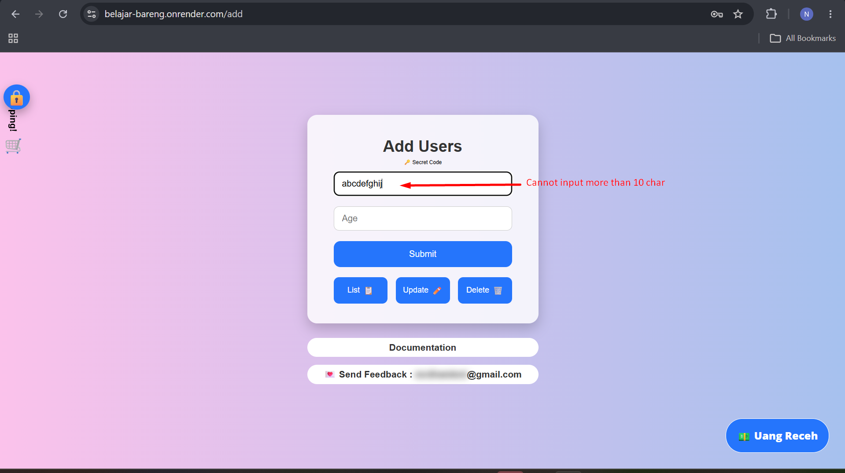

Add User SCN 002 Validate maximum input for age TC 005
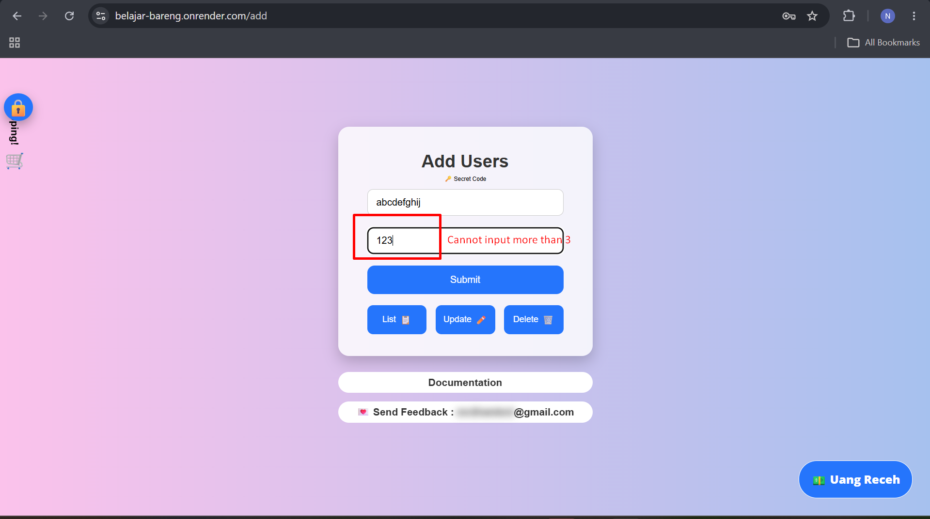

Add User SCN 002 Validate error handling blank input for both username and age TC 006
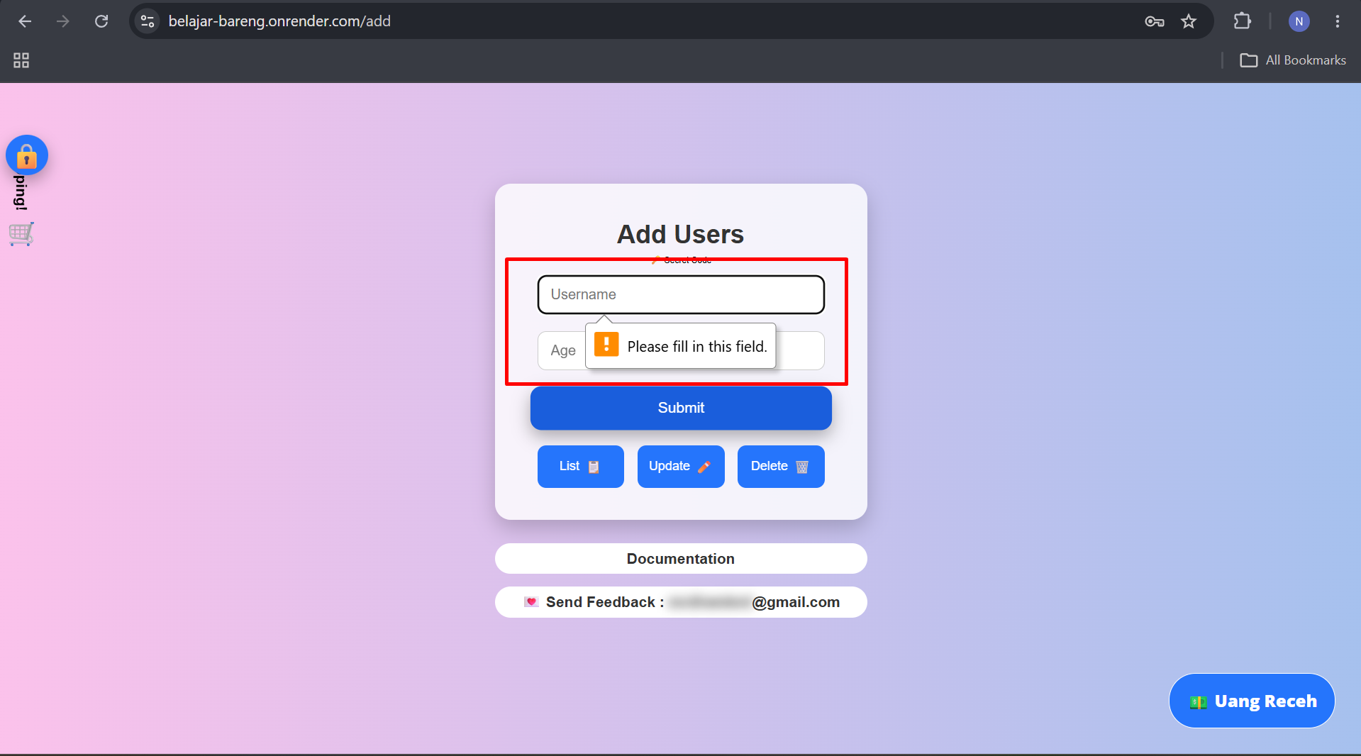

Add User SCN 002 Validate error handling blank input for username only TC 007
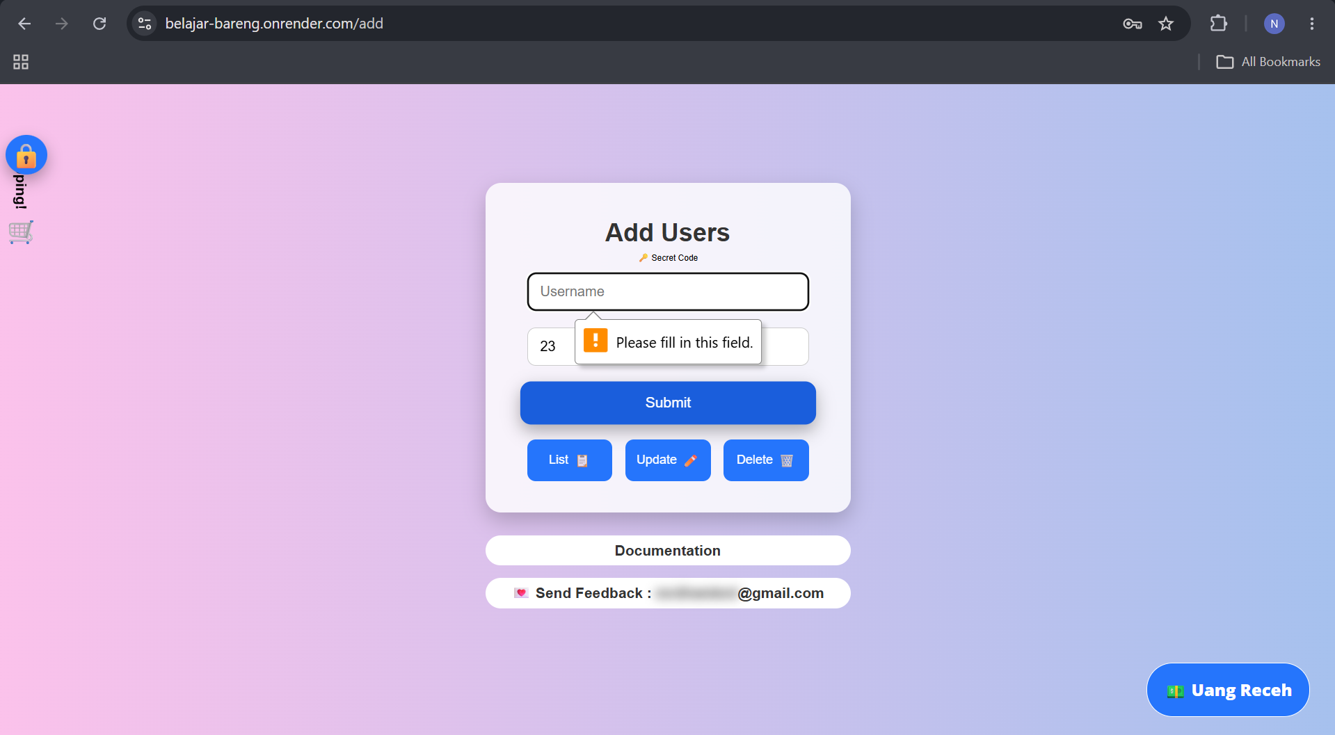

Add User SCN 002 Validate error handling blank input for age only TC 008
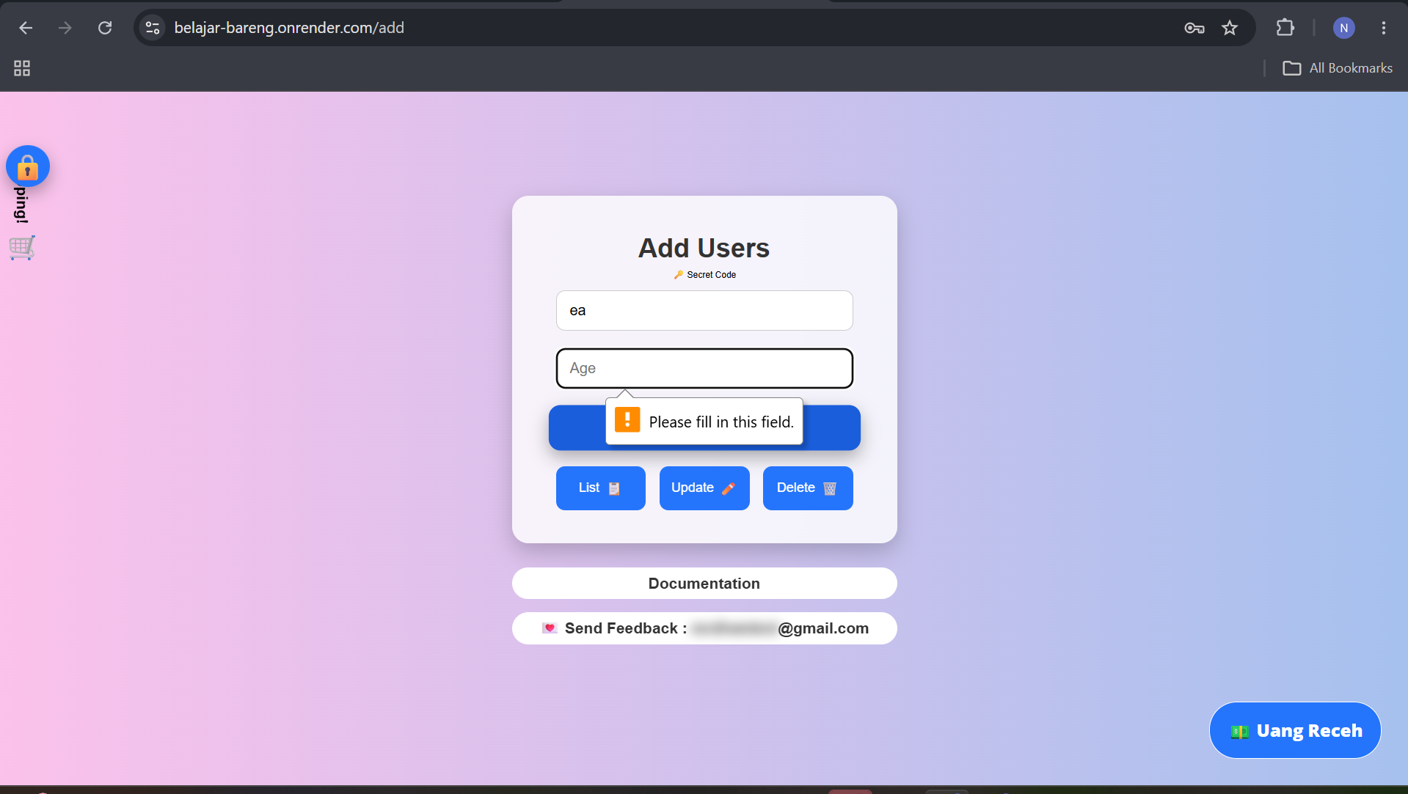

Add User SCN 002 Validate system enforce minimum user age input TC 009
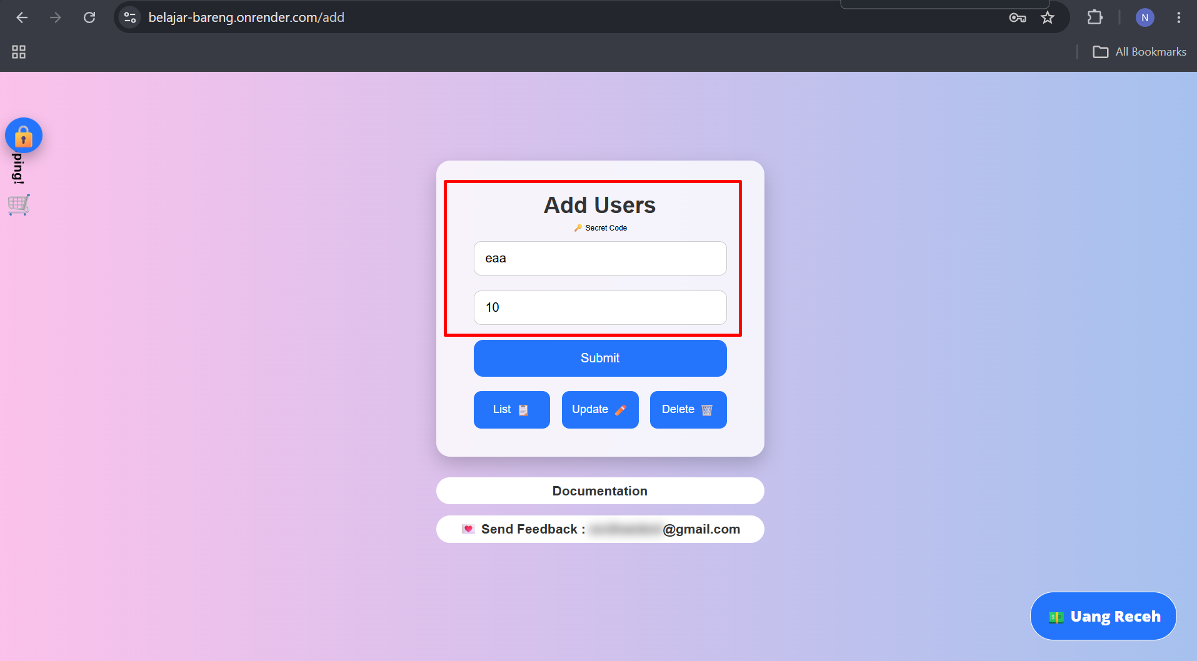
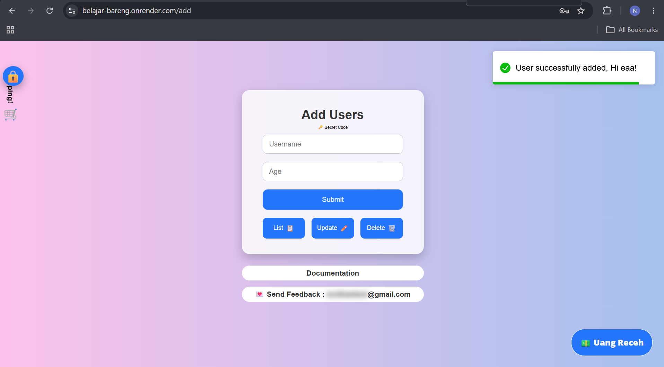

Add User SCN 002 Validate special char and number input on username TC 0010
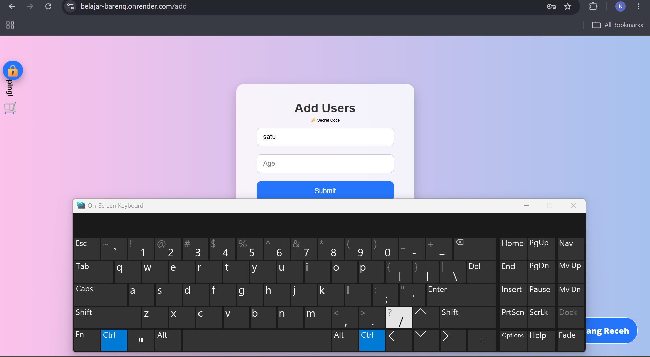

Add User SCN 002 Validate non numeric input on age TC 0011
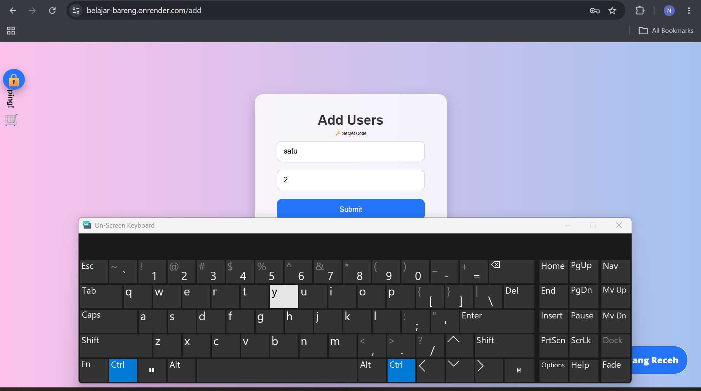

Add User SCN 002 Validate input age with decimal place TC 0012
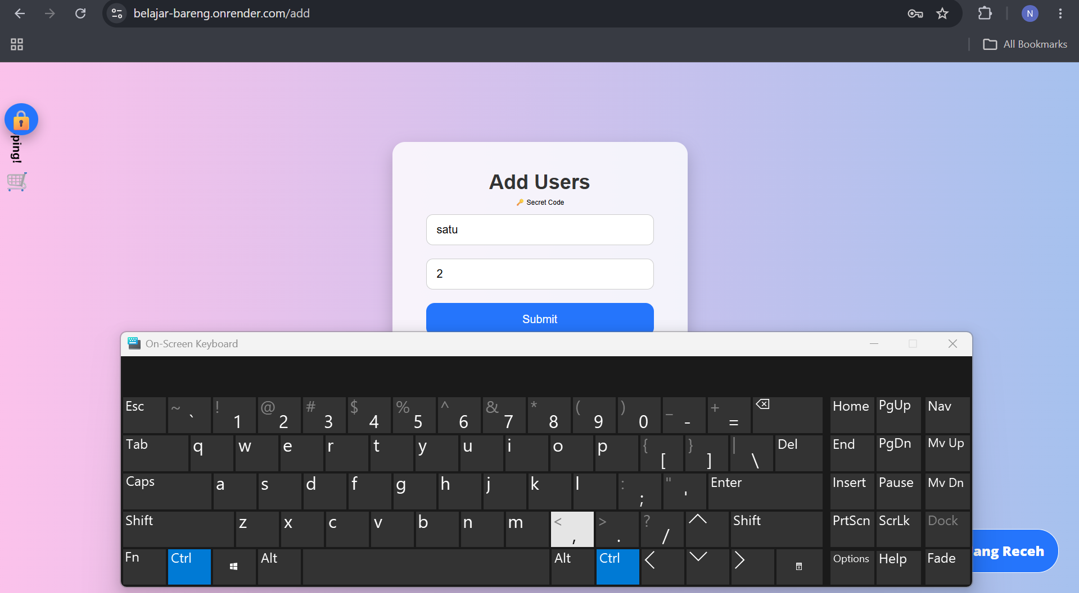

Add User SCN 002 Validate input with negative number TC 0013
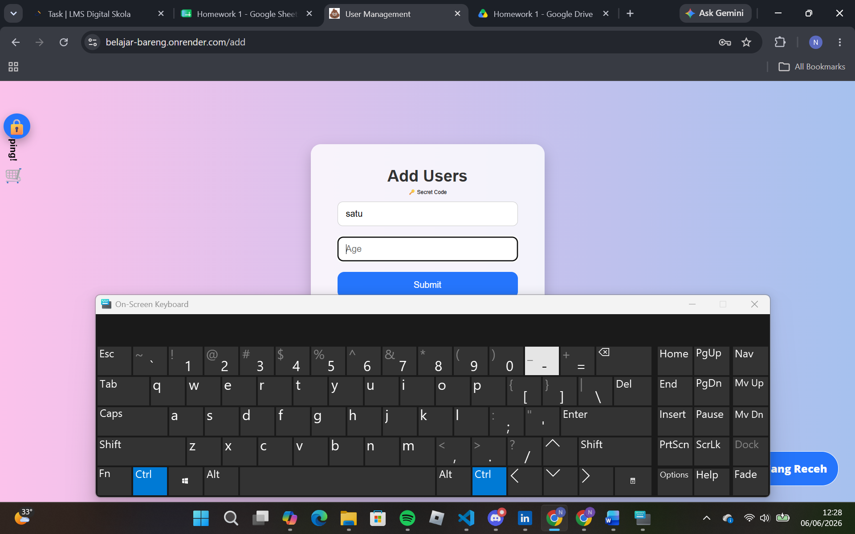

Add User SCN 002 Validate handling for duplicate input TC 0014
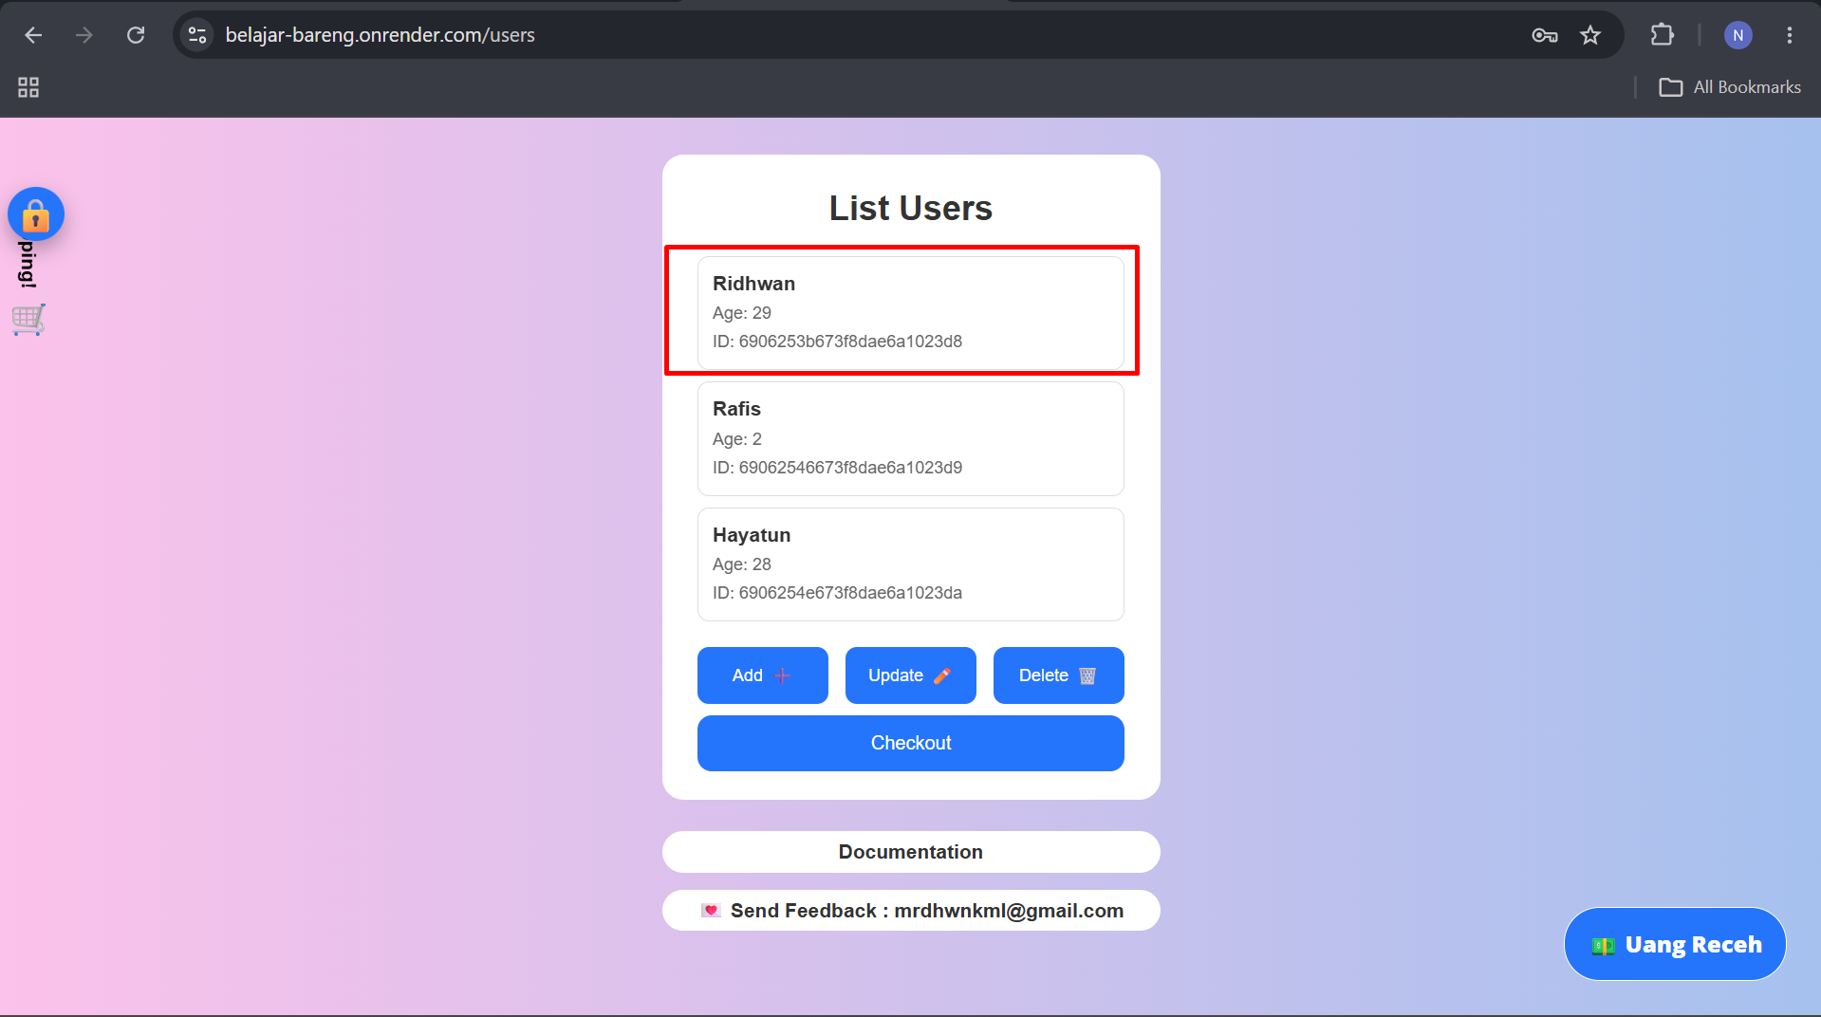
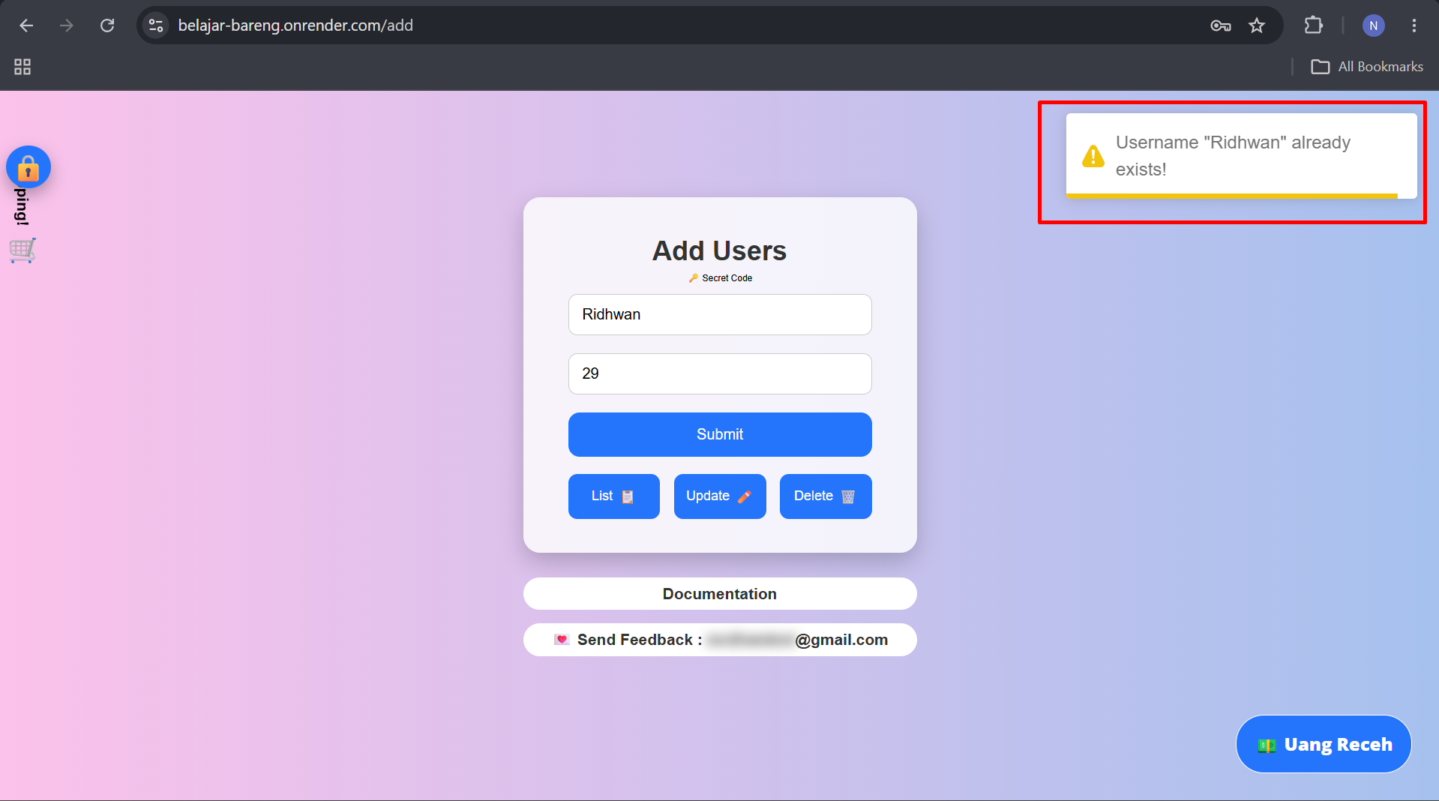

Add User SCN 002 Validate data after add user TC 0015
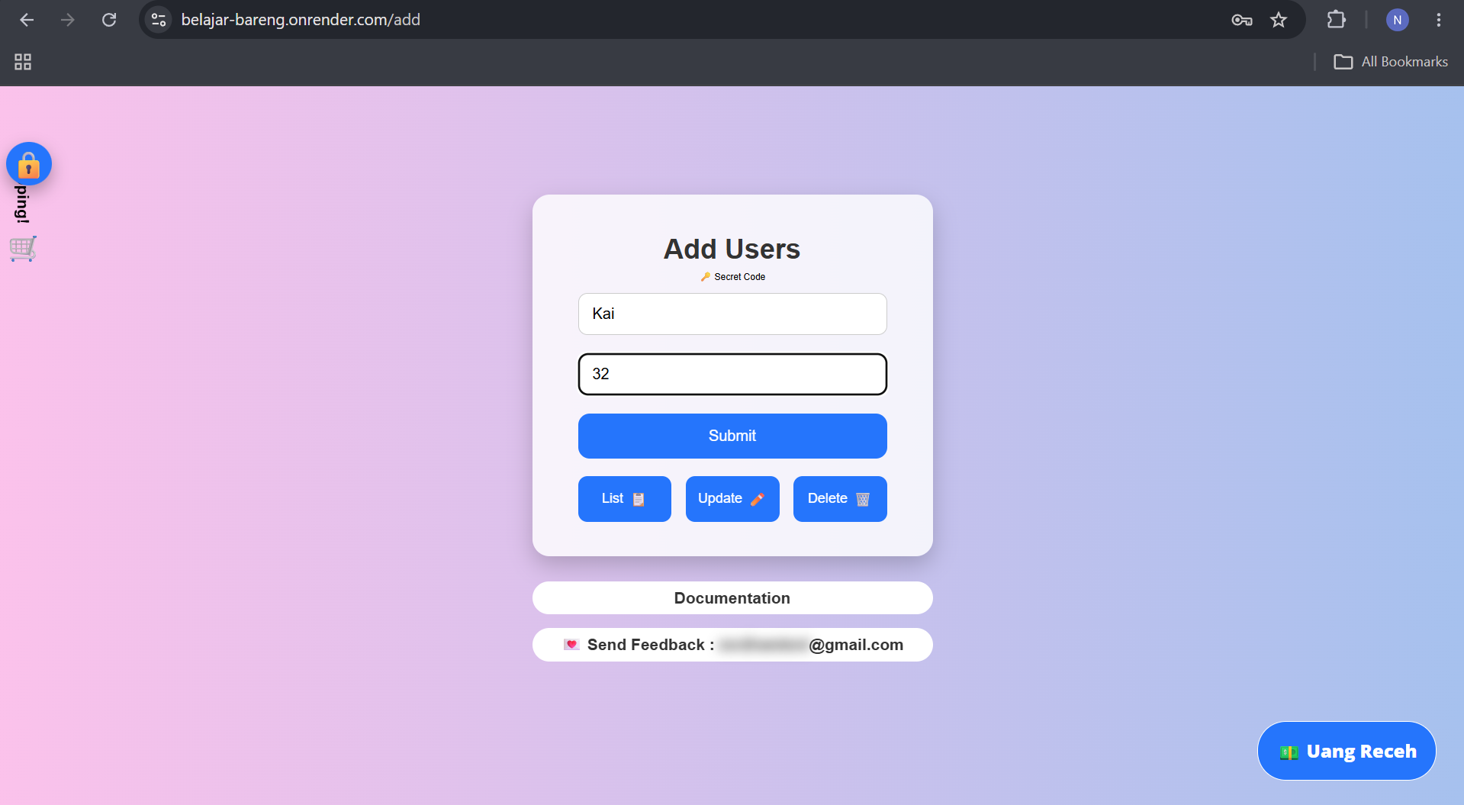
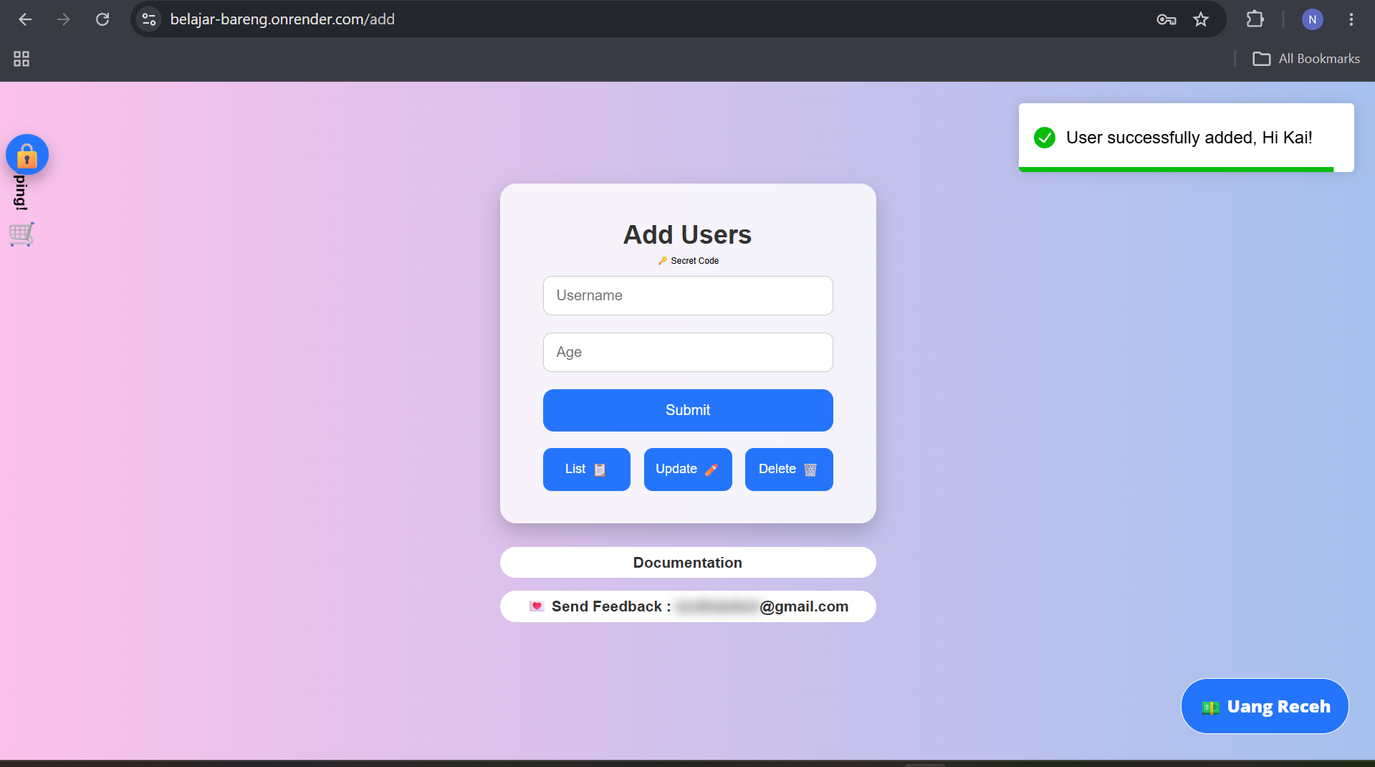
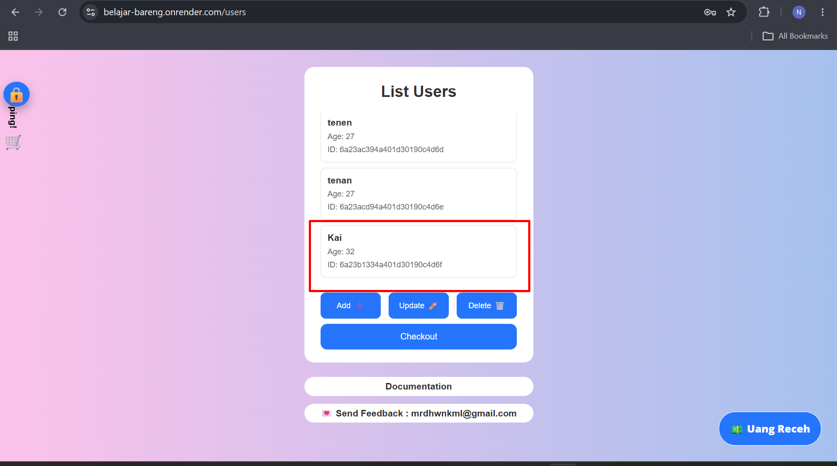

Add User SCN 003 Validate system enforce maximum user age input TC 0016
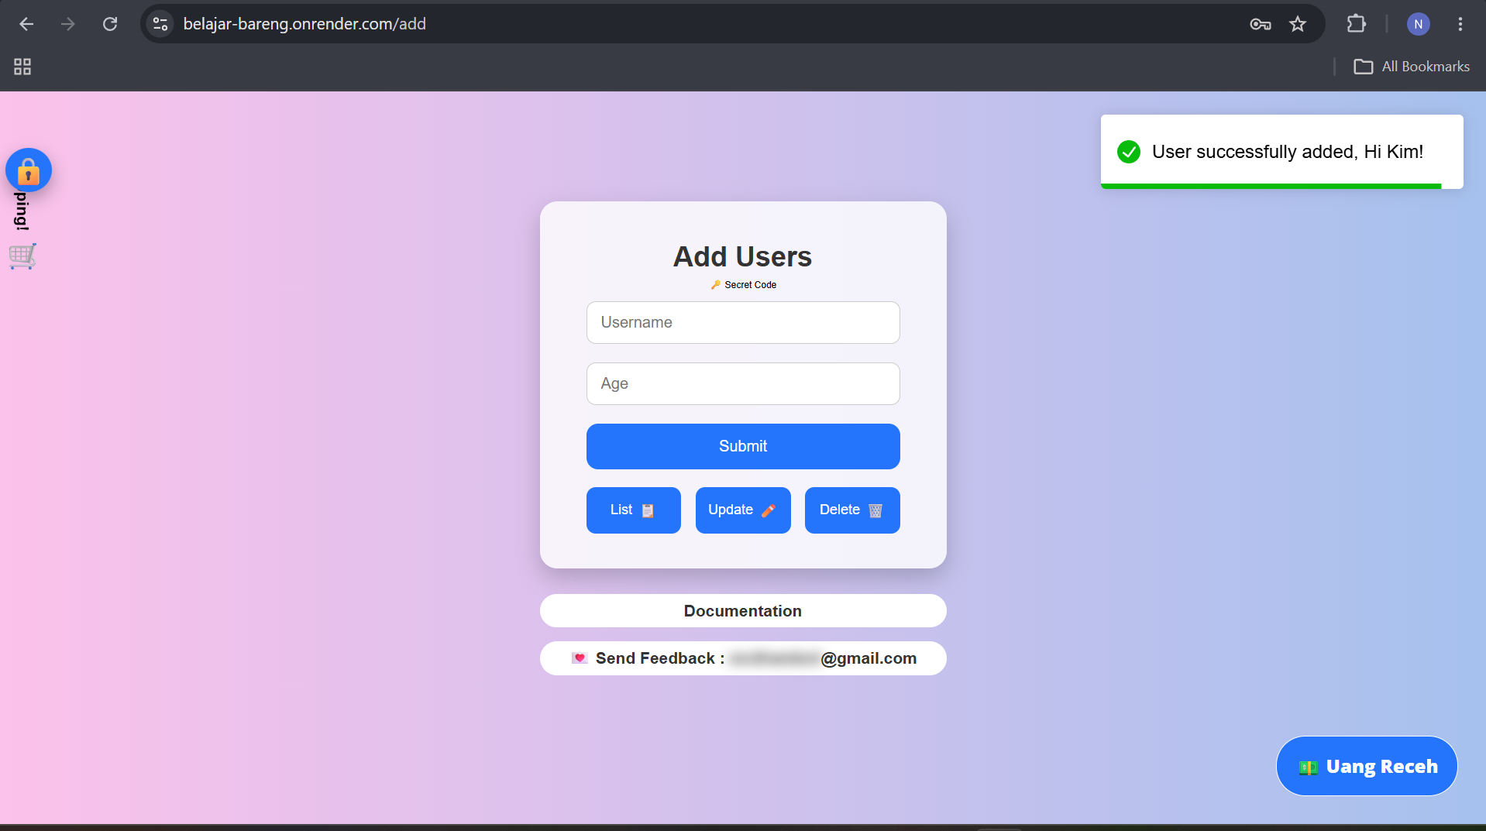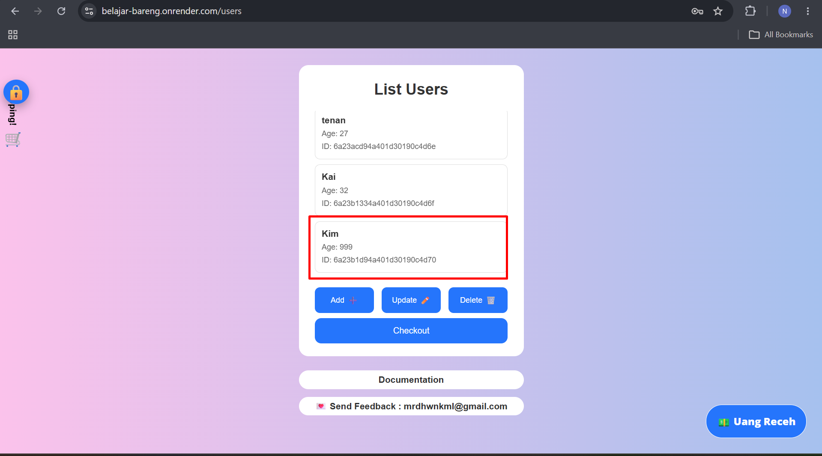

Add User SCN 002 Verify case sensitivity in username input TC 0017
